TECHNICAL SHEET

Designation | Barriers envelopes
Reference(s) | Designation Reference  n°0 (2 x 3 cm) 3135784  n°1 (4 x 3 cm) 3135785  n°2 (3 x 4 cm) 3135783
Product picture | 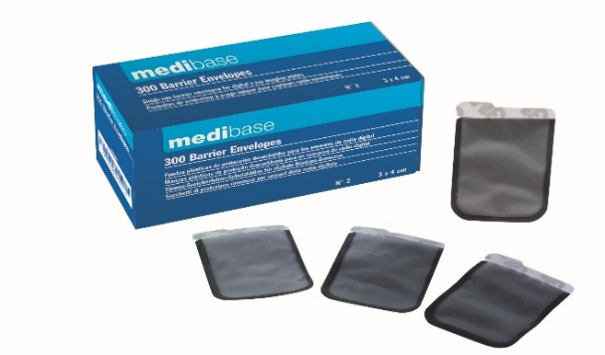
Product description | Single use protection covers for digital sensors.
Characteristics and compositon | Protects digital sensors from degradation and deterioration and from the patient’s saliva through the seal. Easy tearing and disposal of the sensor.  Available in 3 sizes:  - n°0 (2 x 3 cm)  - n°1 (4 x 3 cm)  - n°2 (3 x 4 cm).
Packaging | Box of 100 protections (n°0 and n°1).  Box of 300 protections (n°2).
Shelf life | n.a
Indications of use | Single use.
Legal information | Out of class

Version 2.2 Updated on the 15/11/2022 by RG

