TECHNICAL SHEET

Designation | Cheek retractors Medibase
Article Reference(s) | Adult: 3135081  Child: 3135080
Product picture | 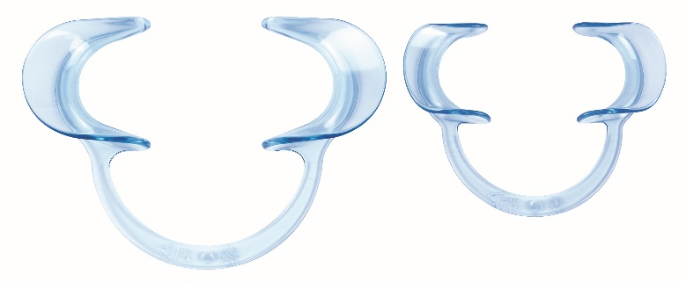
Product description | - Cheek retractors extra resistant and flexible  - Easy to set  - Ideal for scaling, filling and setting brackets
Sterilization instruction | Rinse the disinfection materials thoroughly before autoclaving  - We recommend the safety program of 121°C  - Cycle up to 50x  - Please avoid contact with metal instrument when autoclaving
Characteristics and compositon | - Made from high quality polycarbonate  - Combines high flexibility with very high resistance  - Autoclavable up to 121°C during 15 min  - Dimensions : - adult : 13 cm wide et 9 cm long  - child : 9.5 cm wide et 7.5 cm long  - Available in two sizes: adult and child  Store the product in preference in a dry place
Packaging | - Box of 2 cheek retractors – adult  - Box of 2 cheek retractors – child
Shelf life | n.a
Indications of use | n.a
Legal information | Medical Device of class I  CE Marking  Manufacturer: LARIDENT S.R.L.
Version 5.0 Updated 2022/11/15 by RG

