TECHNICAL SHEET

Designation | Cold bags
Reference(s) | Format Size References  Non woven 13 x 17 cm 3107174  Plastic 13 x 17 cm 3107175
Product picture | 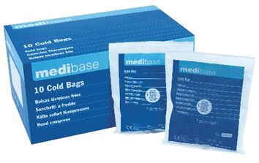
Product description | These cold bags will releave the patient’s pain.
Characteristics and compositon | - Easy to use: a simple pressure on the bag’s center allows to reach a temperature up to - 4°C during 30 minutes.  - Easy to store: can be kept at room temperature.  - Available in 2 patterns: non-woven and plastic.
Packaging | Box of 10 bags
Shelf life | 60 Months
Legal information | Class: IIA.  CE Marking 0546. CERTICHIM Notified body.  Manufacturer: Dispotech

Version 2.0 Date: 15/11/2022 by RG

