TECHNICAL SHEET

Product | COTTON ROLLS
Reference | Number | No. 1 | No. 2 | No. 3
 | Reference | 3135491 | 3135492 | 3135493
Picture | 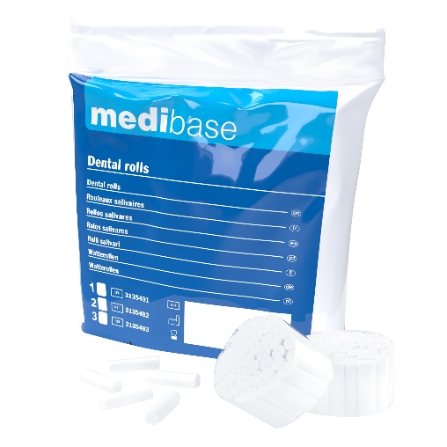
Description | Non-sterile salivary cotton rolls, length 38 mm
Characteristics & Technical data | No. 1 No. 2 No. 3  Diameter Ø 8 mm 10 mm 12 mm  Number of rolls per bag 825 600 450  Number of packages per bag 15 packages of 55 rolls 15 packages of 40 rolls 15 packages of 30 rolls  - 100% cotton non-chlorine bleached
Storage | Bags of 300g
Guarantee | 5 years from the date of manufacture
Shell life
Legal Information | Class I medical device under MDR 2017/745 regulation  EC Mark - Manufacturer: FOMED Industries Inc
Version 2.1 Updated 15/11/2022 By RG

