
TECHNICAL SHEET

Designation | Desinfectant Wipes Medibase
Reference(s) | The box of 100 wipes | 3131820
Reference(s) | The refill bag of 100 wipes | 3131821
Product picture | 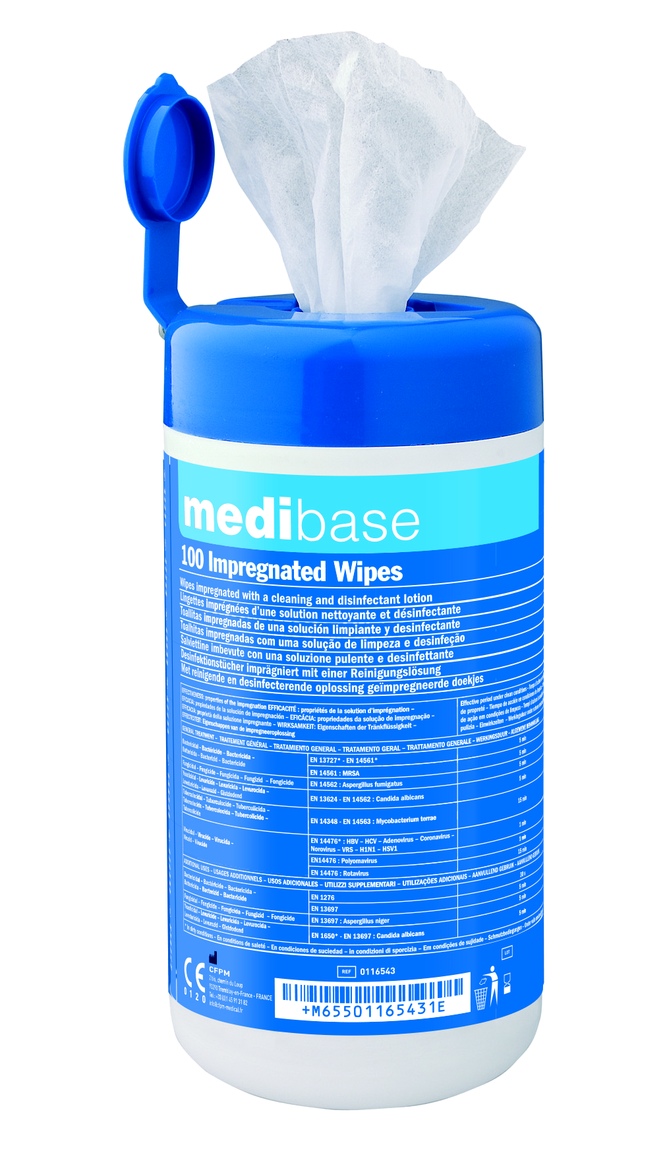  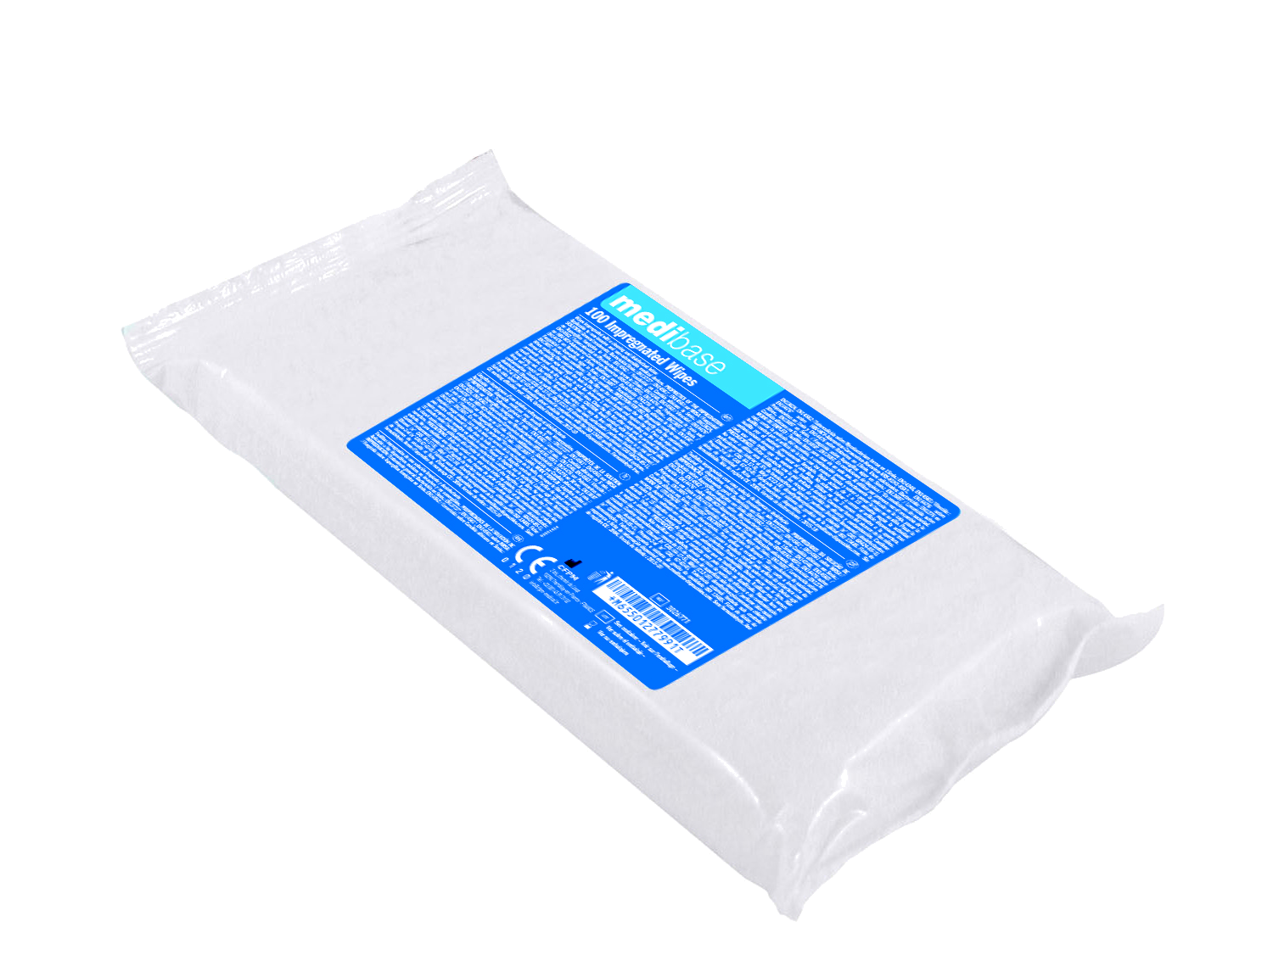
Product description | Wipes impregnated with a disinfectant solution for cleaning and disinfecting non-invasive and non-submersible medical devices (small medical and dental equipment).
Characteristics and compositon | Less than 5% non-ionic surfactants, perfumes including limonene, disinfectants: Ethanol, Alkyl, Dimethylbenzylammonium chloride, Propan-2-ol.  Wipes impregnated with a disinfectant solution for cleaning and disinfecting non-invasive and non-submersible medical devices (small medical and dental equipment).  - Wipes particularly large, thick, strong and sweet.  - Less than 5% non-ionic surfactants, perfumes including limonene, disinfectants: Ethanol, Alkyl, Dimethylbenzylammonium chloride, Propan-2-ol.
  ACTIVITE MICROBIENNE |  | Contact time
  General treatments
  Bactericidal | EN13727* - EN14561 | 5min
   | EN14561: MRSA | 5min
  Fungicidal | EN14562: Aspergillus fumigatus | 5min
  Yeasticidal | EN13624 - EN 14562: Candida albicans | 5min
  Tuberculocidal | EN14348 - EN 14563 : Mycobacterium terrae | 15min
  Virucidal | EN14476* : HBV - HCV - Adenovirus Coronavirus - Novovirus - VRS - H1N1 - HSV1 | 1min
   | EN14476: Polyomavirus | 1min
   | EN14476: Rotavirus | 15min
  Additional uses
  Bactericidal | EN1276 | 30s
   | EN13697 | 5min
  Fungicidal | EN13697: Aspergillus niger | 5min
  Yeasticidal | EN1650* - EN 13697: Candida albicans | 5min
  *In dirty conditions
Packaging | - The box of 100 wipes  The refill bag of 100 wipes
Shelf life | 3 month from the day of opening
Indications of use |   Ready-to-use wipes. Single-use wipes. When using the box for the first time:  - Remove the cover,  - Permanently remove the seal,  - Thread the central wipe through the hole in the cover with clean hands and  - Replace the cover.  - Use the wipe on the equipment.  - Leave on for 30 seconds to 15 minutes according to the antibacterial activity required.  - Leave to dry in the open air.  - Do not rinse.  - Close the flap after each use to prevent the wipes from drying out.
Legal information | Medical Device of class IIA  CE Marking 0459. G-MED Notified body.  Manufacturer : FELT S.A
Version 2.2 Updated 15/11/2022 by RG

