TECHNICAL SHEET

Designation | Disposable dental mirrors
References | Color White Assorted (pink, blue, white, green, yellow)  Reference 3125101 3125100
Product picture | 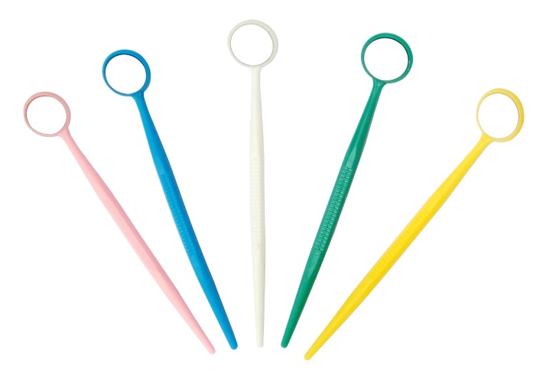
Product description | Mirrors N ° 5 - Outside diameter: 24 mm  Single use only.
Characteristics and composition | - Each mirror is individually wrapped  - Each mirror is protected by a plastic "Peel off" to avoid any scratches  - Lightweight, with anti-slip system  - Mirror:  - Diameter: 20 mm + 0.15 / 0.20 mm  - Thickness: 1.4 mm ± 0.1 mm
Packaging | Economic box of 100 mirrors: white or colors.
Shelf life | n.a
Indications of use | n.a
Legal informations | Class I medical device  Manufacturer: CDM CENTER OF EXCELLENCE LTD.
Version 2.3 Updated the 15/11/2022 by RG

