TECHNICAL SHEET

Designation | Disposable scalpel
References | N°10 N°11 N°12 N°15  3131617 3131618 3131619 3131620
Product picture | 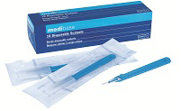  N°10  N°11  N°12  N°15
Product description | Disposable scalpel
Characteristics and composition | - Efficiency Excellent cutting precision  - Taken in hand safe and effective Plastic handle anatomically designed  - Resistance Perfect junction between the blade and the handle  - High quality Stainless Steel blade  - Safety Protection lid  - Sterilized by Gamma irradiation  - Available in 4 model
Packaging | Packaged under individual blister pack
Shelf life | 5 years
Indications d’utilisation | 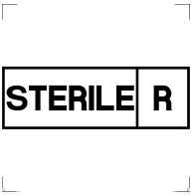
Informations légales | Medical device of class IIa  Marking CE2460- Certifying body: DNV GL NEMKO PRESAFE AS  Manufacturer: RAZORMED INC.
Version 2.0 Updated the 14/11/2022 by RG

