TECHNICAL SHEET

Product Designation | DISPOSABLE TOOTHBRUSHES, TOOTHPASTE IMPREGNATED
Reference | 3138748
Product picture | 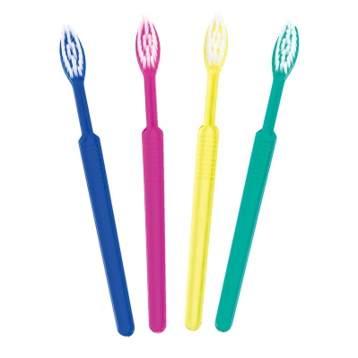
Product description | - Disposable toothbrushes with impregnated toothpaste (invisible tooth gel), each toothpaste is separately packed in PE foil.
Characteristics and composition | Body :  - Total length : 155 mm (± 1.0 mm)  - Width (head) : 12 mm  - Head shape : oval  Tuft :  - Number of tuft holes : 28  - Filament material : nylon 610  - Number of filaments per tuft : 22 (±2)  - Length of filaments : 10 mm (±0.5mm)  - Colour of filament : natural  Pasted solution :  - Ingredients : ethyl alcohol, water, sodium dodecyl sulfate, flavor, sodium saccharin, xylitol, mint, sodium benzoate  - Colour : transparent
Packaging | Box of 100 toothbrushes, in assorted colours (25 pcs of each colour blue, green, pink and yellow).  10 boxes per carton.
Shelf life | 2 years from date of manufacture
Indications of use
Legal information | No class  Quality category: Cosmetic

Version 3.1
Updated 14/11/2022 by RG

