TECHNICAL SHEET

Product Designation | DISPOSABLE TOOTHBRUSHES, TOOTHPASTE IMPREGNATED
Reference | 3138748
Product picture | 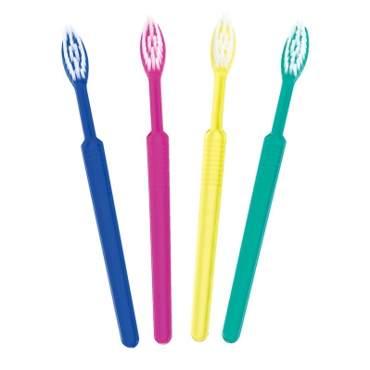
Product description | - Disposable toothbrushes with impregnated toothpaste (invisible tooth gel), each toothpaste is separately packed in PE foil.
Characteristics and composition | Body:  - Total length: 155 mm (± 1.0 mm)  - Width (head): 12 mm  - Head shape: oval  Tuft:  - Number of tuft holes: 28  - Filament material: nylon 610  - Number of filaments per tuft: 22 (±2)  - Length of filaments: 10 mm (±0.5mm)  - Colour of filament: natural  Pasted solution:  INCI CAS N° %  AQUA 7732-18-5 62.8500  SORBITOL 50-70-4 20.0000  GLYCERIN 56-81-5 10.0000  SODIUM LAURYL SULFATE 151-21-3 2.5000  MENTHOL 1490-04-6 2.0000  MENTHA ARVENSAS LEAF OIL 68917-18-0 1.0000  CELLULOSE GUM 9004-32-4 1.0000  SODIUM SACCHARIN 128-44-9 0.2500  CARBOMER 9003-01-4 0.2000  METHYL DIISOPROPYL PROPIONAMIDE 51115-67-4 0.2000
Packaging | Box of 100 toothbrushes, in assorted colours (25 pcs of each colour blue, green, pink and yellow).  10 boxes per carton.
Shelf life | 3 years from date of manufacture
Indications of use
Legal information | Quality category: Cosmetic

Version 3.2 - Updated 03/01/2024

