TECHNICAL SHEET

Designation | EARLOOP MASKS
References | White | Blue | Green | Rose
 | 3135024 | 3135025 | 3135026 | 3135030
Product picture | 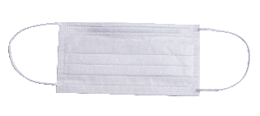  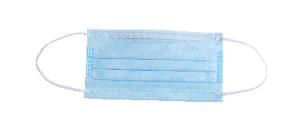  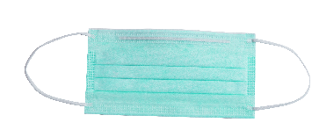  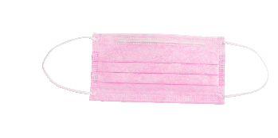  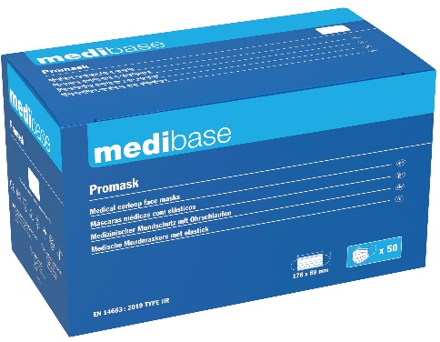
Product  description | Medical Masks with elastics triple thickness without latex and without fiberglasses. In compliance with the Typical standard IIR IN 14683: protective masks against the projections of biological liquids.
Characteristics and  composition | - Bacterial Filtration Efficiency (BFE): >99%.  - Respiratory resistance (ΔP): < 49 Pa/cm².  - Splash resistance: > 120 mm Hg. Propreté microbienne (UFC/g) : ≤ 30  - Inner and top layer: Spunbound polypropylene  - Filter: Meltblown polypropylene  - Dimensions : 17,3 cm x 8,9 cm (± 0,3 cm).  - 3 ply
Packaging | 50 masks per box.  10 boxes per carton.
Shelf life | 3 years  40°C
Indications  of use | 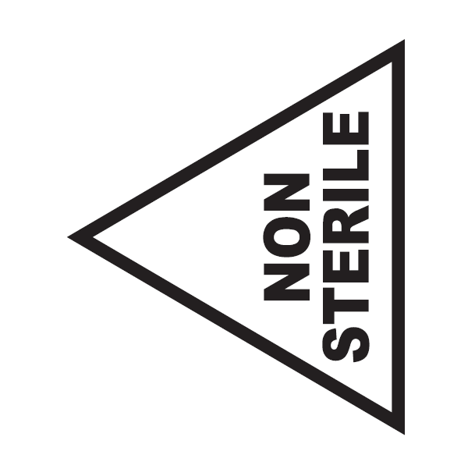  5°C
Legal  information | Medical device of class I under MDR 2017/745 Regulation  EC Mark - Manufacturer A.R. MEDICOM INC. (Shanghai) Co., Ltd.

Version 1.0 – 03/01/2024

