TECHNICAL SHEET

Product Designation | NEEDLES FOR ENDODONTIC CANAL IRRIGATION
Reference | 3125099
Product picture | 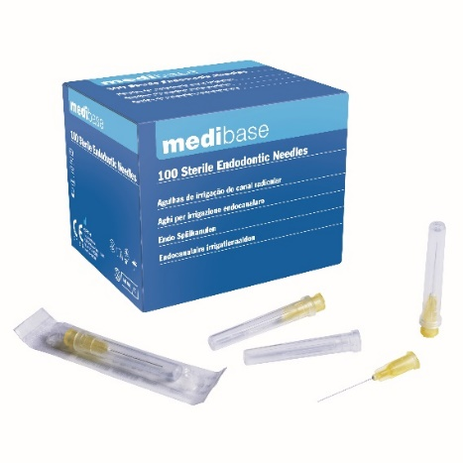
Product description | - Needles for endodontic canal irrigation, individually packed, for single use
Characteristics and composition | - Luer-Lock fixation for a safe fixation : avoid the loosening of the needle during the rinsing, compared to the clipped needles  - Garter stitch  - Efficient with a rebound effect : the resistance moves out the remains of the canal  - Gauge/diameter: 30G – 0,30 mm  - Length : 23 mm
Packaging | box of 100 needles  Each needle is packed individually
Shelf life | 5 years from the manufactured date
Indications of use
Legal information | Medical Device of class I sterile under European Directive 93/42/EEC including Directive 2007/47/CE  CE Marking-0197-TUV RHEINLAND  Manufacturer : CDM CENTER OF EXCELLENCE LTD

Version 3.0 Mise à jour 14/11/2022 par RG

