
TECHNICAL SHEET

Designation | Hydrophilic gauze swabs non sterile Medibase
Reference(s) | 3131818
Product picture | 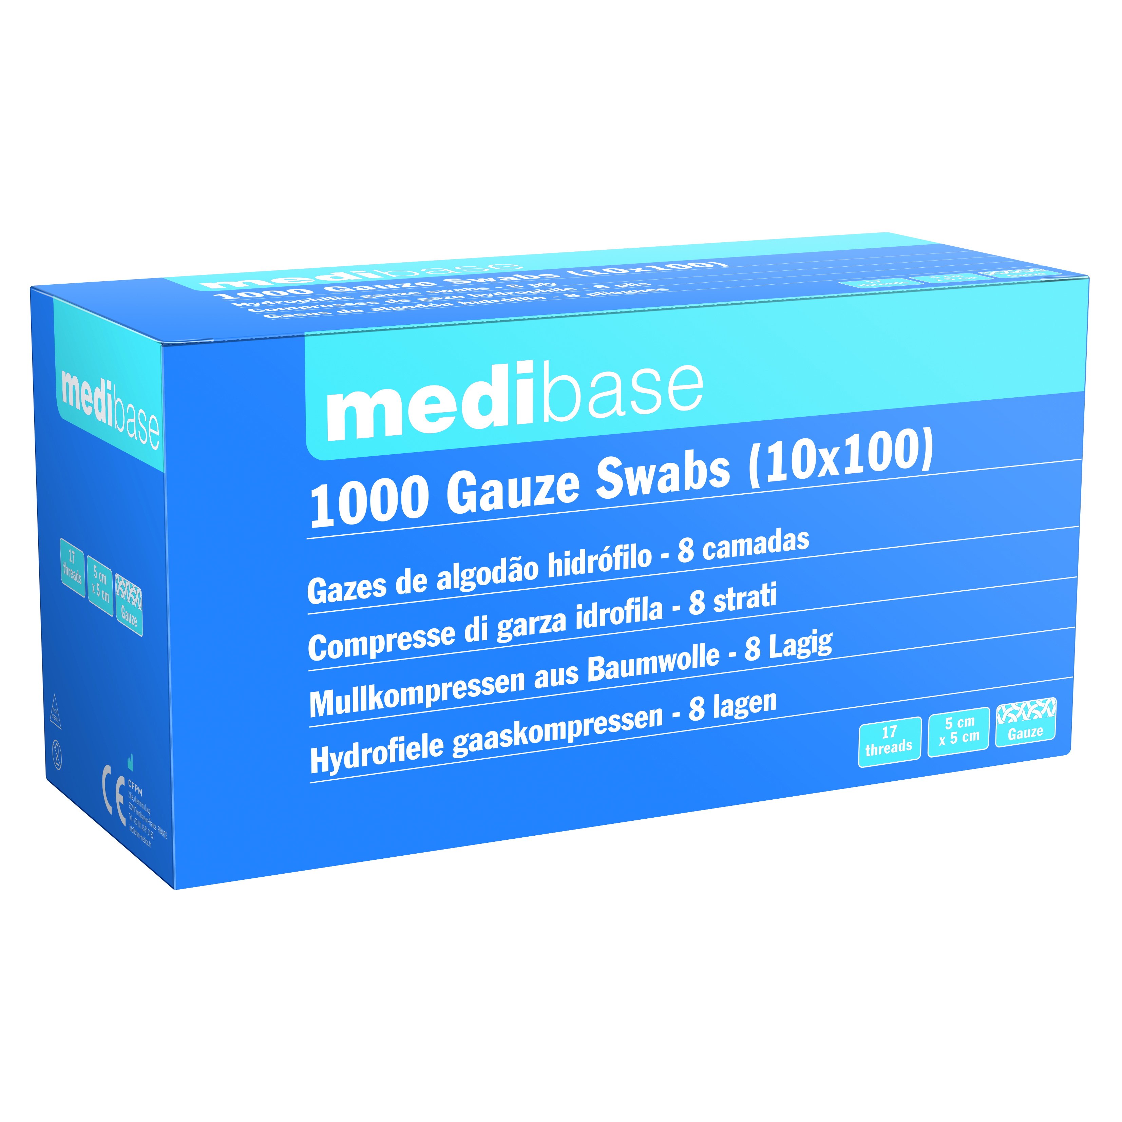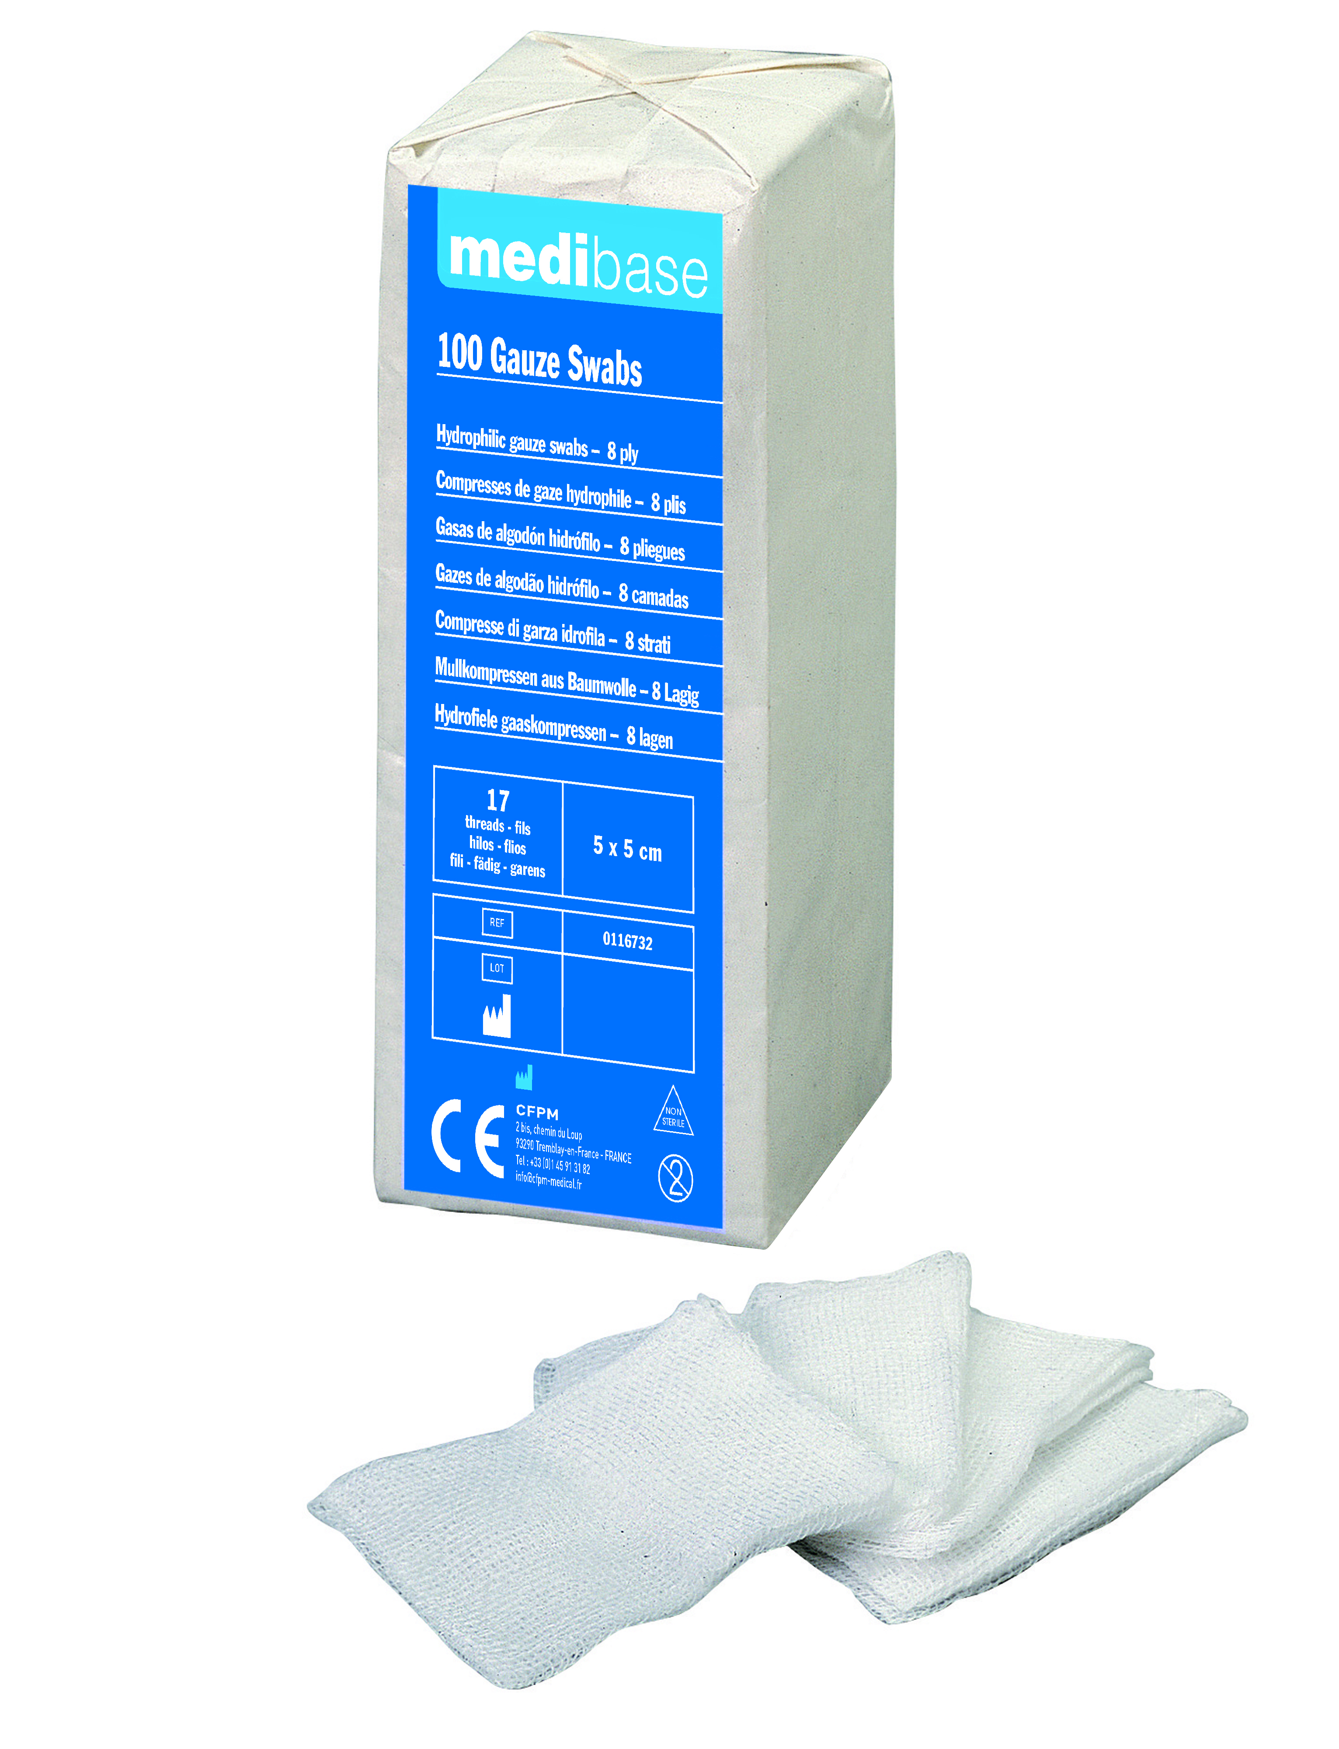
Product description | Pure cotton gauze swabs in 17 threads
  Number of threads | Number of thickness | Folded dimensions | Unfolded dimensions
  17 | 8 | 5 x 5 cm | 14 x 20 cm
Characteristics and composition | - Perfectly white without pigment  - No waste of combing or other  Possible to sterilize with: Vapour, Ethylene Oxide, Radiation
Packaging | 10 packs of 100 swabs each (1 000 swabs)
Shelf life | 5 years
Indications of use | 
Legal information | Medical Device of class I  CE Marking  Manufacturer: SYLAMED
Version 2.0 Updated 14/11/2022 by RG

