  Designation | Hand towels in sheets
References | M/W |  | Z |  | C |  | V
References | 3028749 |  | 3028750 |  | 3176126 |  | 3176127
Product picture | 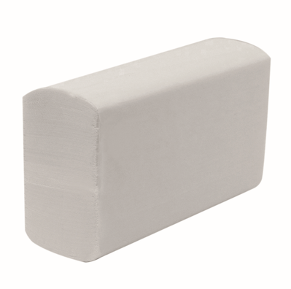
Product description, characteristics and composition | Type of fold | En M/W |  | En Z |  | En C |  | En V
Product description, characteristics and composition | Colour | White |  | White |  | White |  | White
Product description, characteristics and composition | Dimensions | 21,6 x 34cm |  | 23 x 23cm |  | 25 x 30,5cm |  | 25 x 23cm
Product description, characteristics and composition | Paste | Pure cellulose wadding |  | Pure cellulose wadding |  | Pure cellulose wadding |  | 75% recycled cellulose
Product description, characteristics and composition | Basis weight | 17 g/m² |  | 17 g/m² |  | 18 g/m² |  | 19 g/m²
Product description, characteristics and composition | Number of folds | 2 |  | 2 |  | 2 |  | 2
Product description, characteristics and composition | Cartridge packaging | Kraft |  | Kraft |  | Plastic |  | Paper
Product description, characteristics and composition | Sales unit | Carton |  | Polyfilm |  | Carton |  | Carton
Product description, characteristics and composition | Origin | France |  | France |  | Italy |  | Poland
Product description, characteristics and composition | Ecolabel | N°FR/004/005 |  | N°FR/004/005 |  | N°IT/004/034 |  | In progress
Product description, characteristics and composition | Food contact | YES |  | YES |  | NO |  | NO
Product description, characteristics and composition | Compatibility | Tork H2 |  | Tork H3 |  | Tork H3 |  | Tork H3
Product description, characteristics and composition | DESL* Technology | YES |  | YES |  | NO |  | NO
Product description, characteristics and composition | *DESL : naturally biodegradable, stronger, more hygienic
Packaging | M/W folded: 27 x 100-sheet cartridges (2,700 sheets)  Z-fold: 25 x 150-sheet cartridges (3,750 sheets)  C-fold: 24 x 153-sheet cartridges (3,672 sheets)  V-fold: 16 x 225-sheet cartridges (3600 sheets)
Shelf life | N/A
Indications of use | N/A
Version 2
TECHNICAL SHEET

