
TECHNICAL SHEET

Designation | Perforated plastic impression tray Medibase
Reference(s) | 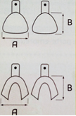
  Type | Upper |  |  | Lower |  |  | Upper/Lower |  |  | Assorted
  Size | Large | Medium | Small | Large | Medium | Small | Upper left / Lower right | Upper right/  Lower Left | Anterior | Assorted
  Ref | 3135484 | 3135483 | 3135490 | 3135482 | 3135481 | 3135489 | 3135487 | 3135486 | 3135488 | 3135485
  Size A*  (mm) | 70 | 65 | 60 | 73 | 70 | 67 | 56 | 56 | 58
  Size B*  (mm) | 60 | 55 | 50 | 60 | 52 | 50 | 50 | 50 | 34
Visual | 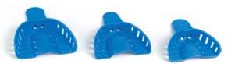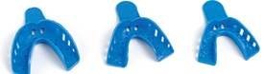
Description | Disposable plastic impression trays with excellent retention, handling and rigidity.
Characteristics and compositon | - Perforated  - Excellent retention  - Hard plastic  - Easy to use  - Cold disinfection
Packaging | Available in 9 sizes + 1 assorted pack.
Shelf life | n.a
Indications of use | 
Legal information | Medical device of Class 1  Manufacturer: FOMED Industries Inc

Version 1.2 Updated 15/11/2022 by RG

