Designation | Micro-applicators
References | SIZE COLOR PACKAGING REFERENCE  REGULAR BLUE Box of 4 tubes each containing 100 micro-applicators 3101006  BLUE/PINK 3101007  BLUE/ORANGE 3101008  FINE BLACK Tube of 100 micro-applicators 3101009  SUPER FINE WHITE 3101010
Product picture | 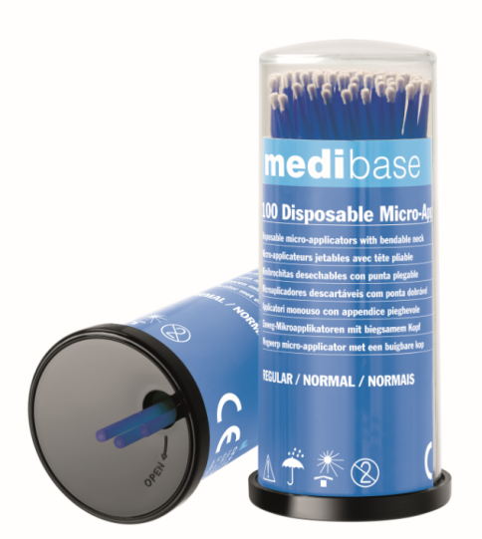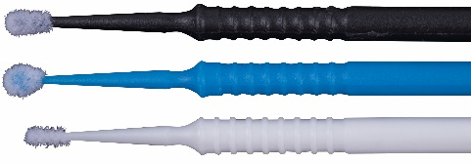
Product description | Disposable micro-applicators with foldable head.
Characteristics and composition | Polypropylene handle, with breakable tip: allows to differentiate the micro-Applicators between them!  Nylon bristles.  Overall length: 102 mm  Tube packaging: hygienic dispensing
Packaging | REGULAR: box of 4 tubes each containing 100 micro-applicators  FINE / SUPER FINE: tubes of 100 micro-applicators
Shelf life | N/A
Indication of use | Regular fibers, non-absorbent and lint-free. The solutions are held in suspension between the fibers to prevent dripping and allow perfect application. Easy access to all areas of application thanks to the foldable head.  Disposable: discard after use.  For use with silanes, adhesives, etching gel, hemostatic solutions, cavity bottoms and plaque developers.  Store away from light and dust in a cool, dry place.
Legal informations | Class I medical device  Manufacturer: AKZENTA INTERNATIONAL CHINA
Version 1.2 Updated the 15/11/2022 by RG
TECHNICAL SHEET

