TECHNICAL SHEET

Designation | Mini-brushes
References | 3134139
Product picture | 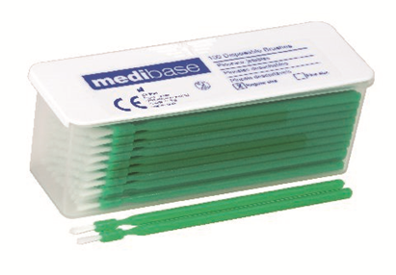
Product description | Mini-brushes.
Characteristics and composition | – Regular fibres for perfect application.  – Length: 105 mm.  – Flexible for easy access to all possible application zones.  – Economical: the brushes’ high precision reduces the amount of solution to be used
Packaging | Box of 100 mini-brushes.
Legal informations | Medical device, class: I.  Manufacturer: NOVOBRUSH

Version 1.1 Updated the 15/11/2022 by RG

