TECHNICAL SHEET

Product Designation | PAPER MIXING PADS
Reference | Désignation Référence  Lot de 3 blocs de 100 feuilles, taille 4 * 4 cm 3143352  Lot de 3 blocs de 100 feuilles, taille 7 * 8 cm 3143351  Lot de 3 blocs de 100 feuilles, taille 9 * 15 cm 3143350  Lot de 3 blocs de 100 feuilles, taille 14 * 20 cm 3143349
Product picture | 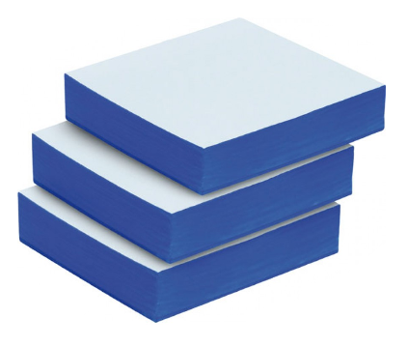
Product description | Mixing pads of paper covered with polyethylene
Characteristics and composition | Non-skid base: Avoids the pad from slipping when spatulation
Packaging | Pack of 3 pads, Pads of 100 sheets each, individually wrapped in plastic film
Legal information | Medical device of class I, Manufacturer: MGK
Version 3.0 Mise à jour 14/11/2022 par RG

