TECHNICAL SHEET

Product | PHOTO RETRACTORS
Reference | Adult : 3135082  Infant : 3135084
Picture | 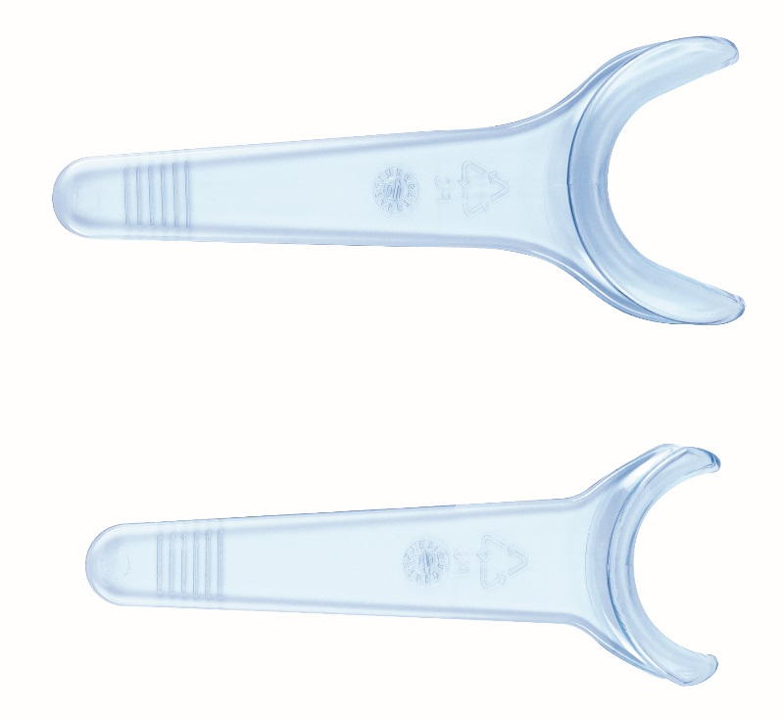
Description | With an extra-long handle, it is ideal for clinical photography
Sterilization advice | Rinse disinfectants thoroughly before autoclaving.  - Autoclavable at 134°C for 18 min.  - Cycle: up to 50 x  - Do not put metal in contact in the autoclave
Characteristics & Technical data | - Non-reflective  - Made of high-quality polycarbonate  - Sterilizable in autoclave at 134 ° C for 18 min  - Available in two sizes: adult and child  Store the product preferably in a dry place.
Storage | - Box of 2 adult cheeks retractors  - Box of 2 child cheeks retractors
Garantee | More or less 5 years depending on the number of sterilization cycles.
Shell life | n.a
Legal Information | Class I medical  CE marking  Manufacturer: LARIDENT S.R.L.
Version 2.2 Updated 15/11/2022 by RG

