TECHNICAL SHEET

Designation | Plastic pipettes
References | 3125132
Product picture | 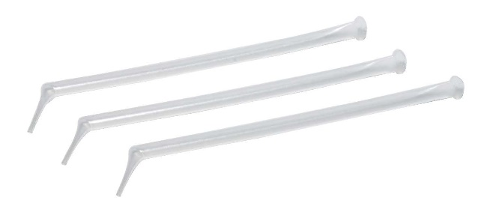  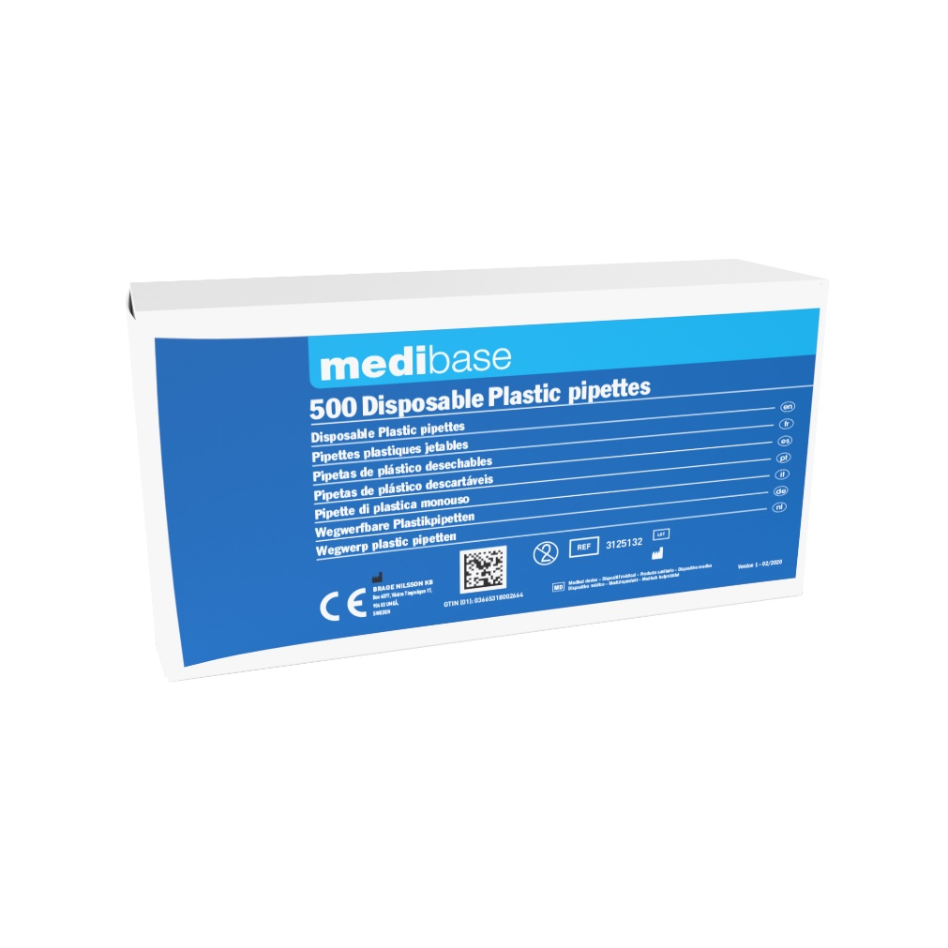
Product description | Single use plastic pipettes for precise dental liquid sampling.
Characteristics and composition | – 1 cm fine and solid point.  – Capacity :0.5 ml.
Packaging | Box of 500 plastic pipettes.
Shelf life
Legal informations | Class I.  Manufacturer: BRAGE NILSSON KB

Version 1.1 Updated the 15/11/2022 by Robin GERVAIS

