
TECHNICAL SHEET

Designation | PVC Mixing pads
Reference(s)
  Dimensions | Reference
  7 x 8 cm | 3143353
  14 x 8 cm | 3143354
Product picture | 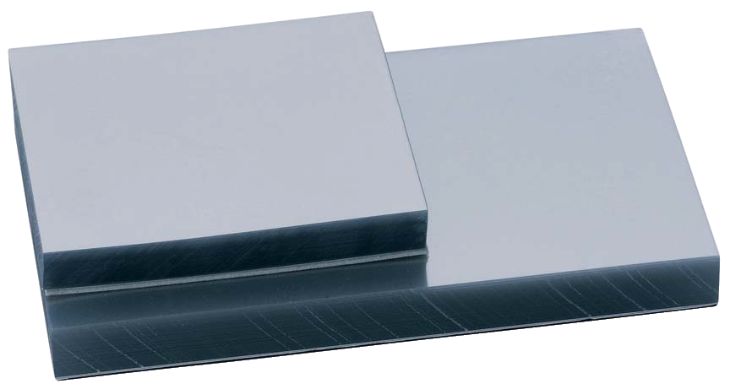
Product description | PVC blocks of transparent sheets
Characteristics and compositon | Non toxic PVC  - Use: Particularly suitable for cements  - Non-skid base: Foam, provides stability during mixing on all dental work  - Sheets: More solid than paper, no liquid can penetrate the PVC
Packaging | - Pads of 100 sheets each  - Individually wrapped in plastic film
Shelf life | n/a
Indications of use | n/a
Legal information | Medical device of class I, Manufacturer : MGK
Version 2.0 Updated the 14/11/2022 by RG

