
TECHNICAL SHEET

Designation | Saliva ejectors – fixed tips
References | Colours | transparent | white
References | Reference | 3135200 | 3135201
Product Picture | 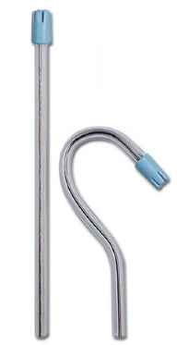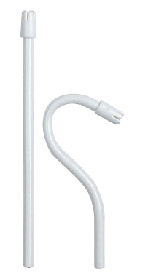
Product description | Easy shaping because of copper wire reinforcement  - Tips : small, smooth and rounded  - Ideal for all uses, even on irritated walls  - Diameter : 6,5 mm  - Lenght : 15 cm
Characteristics and composition | Made from PVC
Packaging | - Store at room temperature in a dry and ventilated area  - Plastic bag of 100 units
Shelf life | 5 years from the date of manufacture
Indications of use | 
Legal information | Medical Device of class IIA  CE marking- 0051-IMQ S.p.A  Manufacturer: ASA DENTAL
Version 1.2 Updated on the 15/11/2022 by RG

