
TECHNICAL SHEET

Designation | Saliva ejectors – removable tips
Reference(s)
  Colours | Translucent | Blue | Green | Orange | Pink
  Reference | 3127251 | 3127252 | 3127253 | 3127254 | 3127255
Product picture | 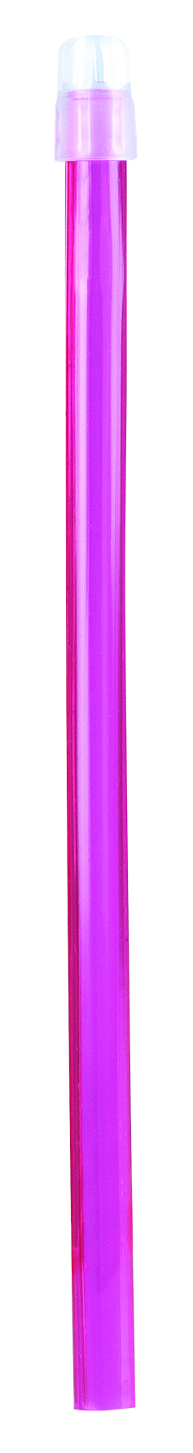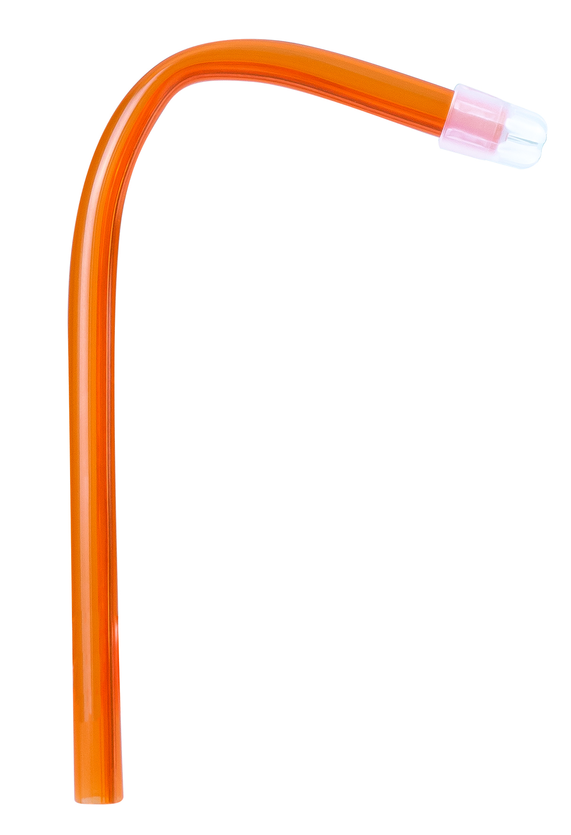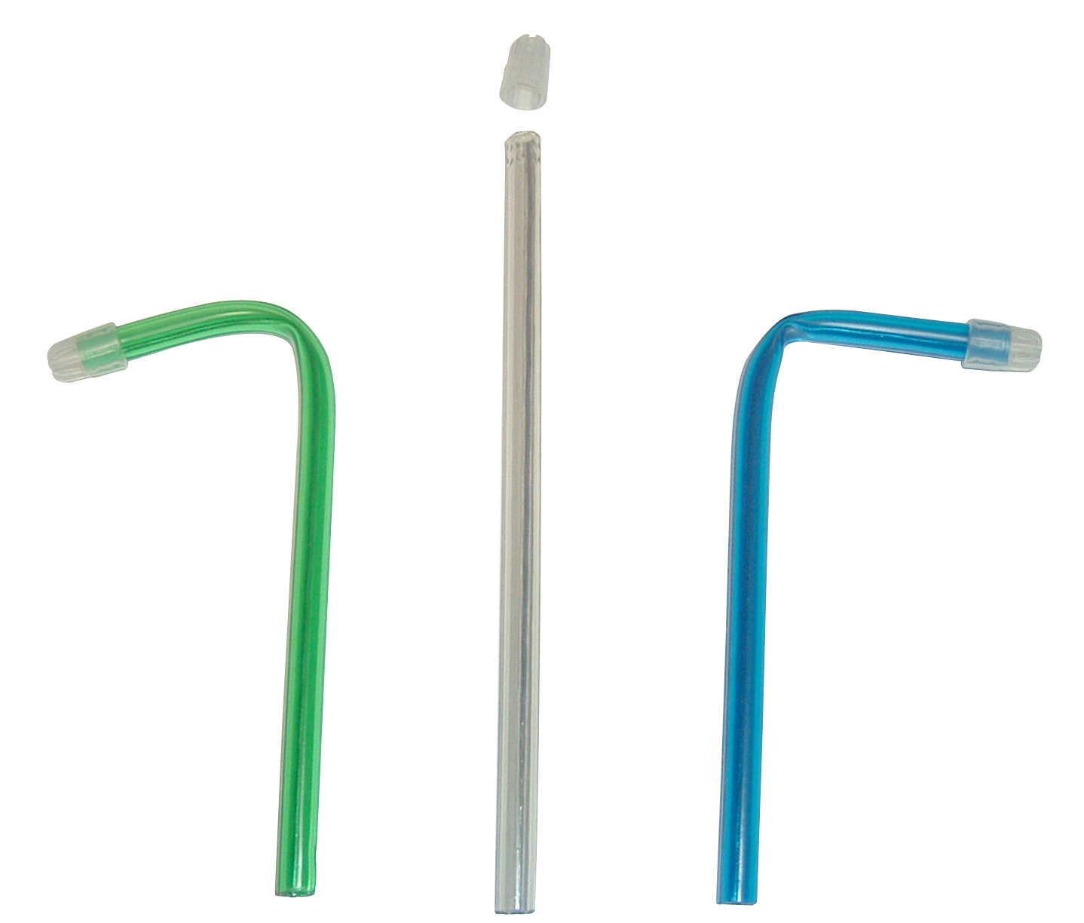
Product description
  Formatting easy | because armed with a copper metallic wire
  Tips | removable, little, smooth, rounded
  Use | ideal for all uses, even on irritated mucous membranes
  Diametre | 6.5 mm
  Length | 15 cm
Characteristics and compositon | Made from PVC
Packaging | - Store at room temperature in a dry and ventilated area  - Plastic bag of 100 units
Shelf life | n.a
Indications of use | 
Legal information | Medical Device of class IIA  CE 0051 Marking- Organismo de certificación: IMQ S.p.A  Manufacturer: EURONDA
Version 1.2 Updated 15/11/2022 by RG

