TECHNICAL SHEET

Designation | POWDER FREE LATEX EXAMINATION GLOVES SOFT
Reference | XS -5/6 | S – 6/7 | M – 7/8 | L-8/9 | XL-9/10
 | 3135786 | 3135787 | 3135788 | 3135789 | 3135790
Visual product | 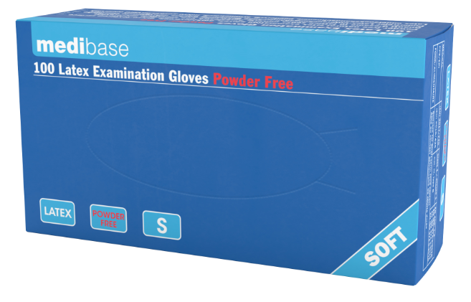
Product description | - Powder-free latex examination gloves, chlorinated.  - Non-sterile, with micro-textured surface and rolled cuffs.  - Polymer coated
Characteristics and composition | XS -5/6 S – 6/7 M – 7/8 L-8/9 XL-9/10  Width of the palm (mm) 70-79 80-89 90-99 100-109 110-119  Thickness at the finger 0.15 ± 0.02 (0.14 – 0.16)  Thickness at the palm 0.12 ± 0.02 (0.12 – 0.14)  - Protein content: max 50 µg/dm².  - Powder level: max 2 mg/dm².  - In compliance with the standards: EN 455-1/2/3/4, EN 420, EN 374-1/2/4/5
Packaging | Box included 100 gloves (± 2 gloves).  10 boxes per carton.
Shelf life | 5 years from the date of manufacture.
Indication for use
Legal information | Medical Device of class I under MDR 2017/745  Class III personal protective equipment under Regulation 2016/425  CE Marking
Version 1.1
Update 15/11/2022 by RG

