TECHNICAL SHEET

Product Designation | DISPOSABLE SYRINGES FOR SINGLE-USE
Reference | Content 2,5 ML 5 ML 10 ML 20 ML  Reference 3125103 3125105 3125102 3125104
Product picture | 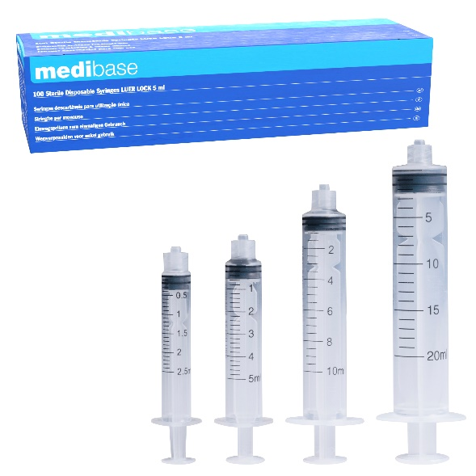
Product description | - Disposable syringes for single-use for endodontic canal irrigation
Characteristics and composition | - Luer-lock thread for a safe fixation of the needle  - Latex free piston  - Sterile individual package
Packaging | Content Graduation Number of serynges per box  2.5 ML 0.1 ML 100  5 ML 0.2 ML 100  10 ML 0.5 ML 100  20 ML 1 ML 80
Shelf life | 5 years from the manufactured date
Indications of use | 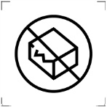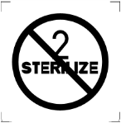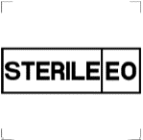
Legal information | Medical Device of class IIA  CE Marking- 0197-TUV RHEINLAND  Manufacturer: CDM CENTER OF EXCELLENCE LTD

Version 1.2
Updated 15/11/2022 by RG

