
TECHNICAL SHEET

Designation | Hydrophilic gauze swabs sterile Medibase
Reference(s) | 3135500
Product picture | 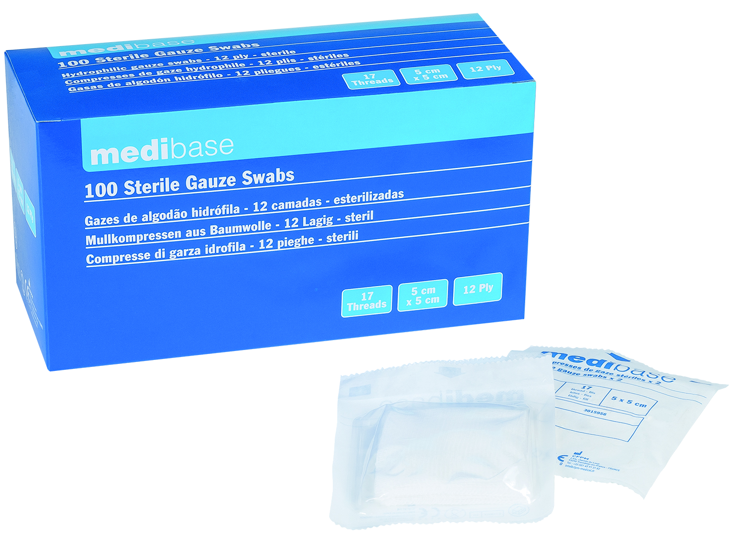
Product description | - Dimensions folded: 5*5 cm  - Number of threads: 17  - Number of plies: 12  - Sterilisation: Ethylene Oxide
Characteristics and compositon | - Dimensions folded: 5*5 cm  - Number of threads: 17  - Number of plies: 12  - Sterilisation: Ethylene Oxide
Packaging | Carton of 100 swabs (50 sterile pouches of 2 swabs)
Shelf life | 5 years
Indications of use | 
Legal information | Medical Device of class I  CE 0123 Marking- Certifying body: TUV PRODUCT SERVICE  Manufacturer: FOMED Industries Inc
Version 2.0 Updated 14/11/2022 by RG

