
TECHNICAL SHEET

Designation | Hydrophilic gauze swabs sterile Medibase
Reference(s) | Conditioning | 50 blisters of 2 swabs | 40 blisters of 2 swabs
Reference(s) | Dimensions | 5 x 5 cm | 7.5 x 7.5 cm
Reference(s) | Reference | 3135500 | 3135504
Product picture | 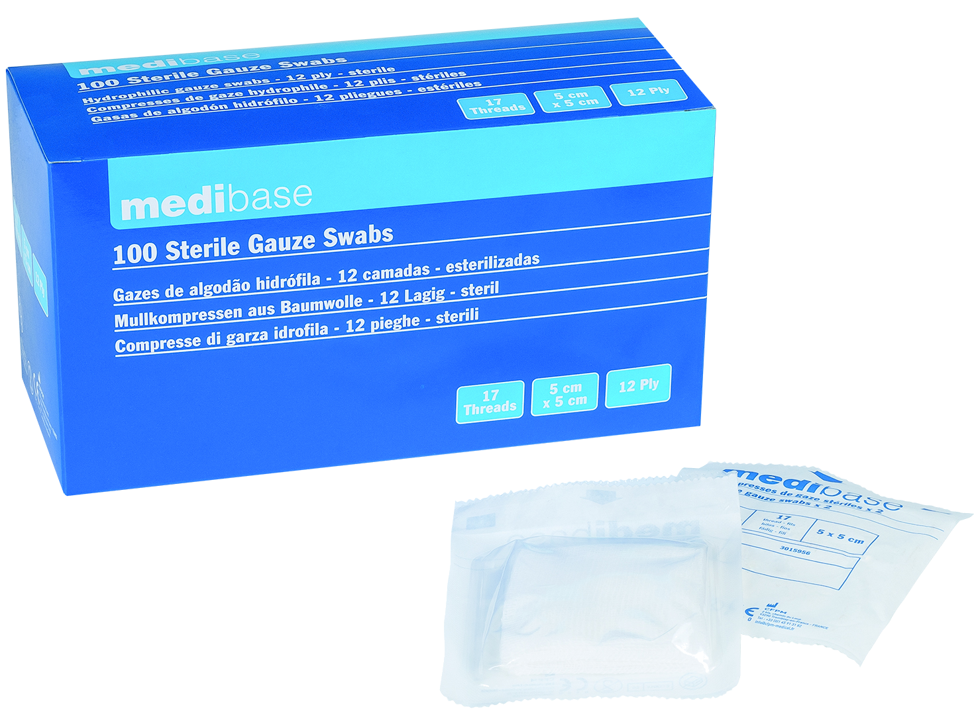
Product description | Pure cotton gauze swabs.  - Number of threads: 17  - Number of plies: 12  - Sterilisation: Ethylene Oxide
Characteristics and composition | - Perfectly white with no colouring matter  - No combing or other waste
Packaging | Box of 100 swabs: 50 sterile blisters of 2 swabs.  Box of 80 swabs: 40 sterile blisters of 2 swabs.
Shelf life | 5 years
Indications of use | 
Legal information | Medical Device of class I sterile  CE 0123 Marking- Certifying body: TUV PRODUCT SERVICE  Manufacturer: FOMED Industries Inc
Version 2.1 Updated 03/01/2024

