
TECHNICAL SHEET

Designation | Sterile needles Medibase (100)
Reference(s)
   | Description | G | Ø | Longueur | Reference
  Périapicales | Extra-fine | 30 G | 0,30 | 16 mm | 3114384
  Périapicales | Extra-fine | 30 G | 0,30 | 21 mm | 3114385
  Périapicales | Fine | 27 G | 0,40 | 8 mm | 3114386
  Périapicales |  | 25G | 0,50 | 36 mm | 3114387
  Périapicales |  | 27 G | 0,40 | 21 mm | 3114388
  Intraseptales | Fine | 27 G | 0,40 | 16 mm | 3114389
  Intraligamentaire | Extra-fine | 30 G | 0,30 | 12 mm | 3114390
  Tronculaires | Extra-fine | 30 G | 0,30 | 25 mm | 3114391
Visual | 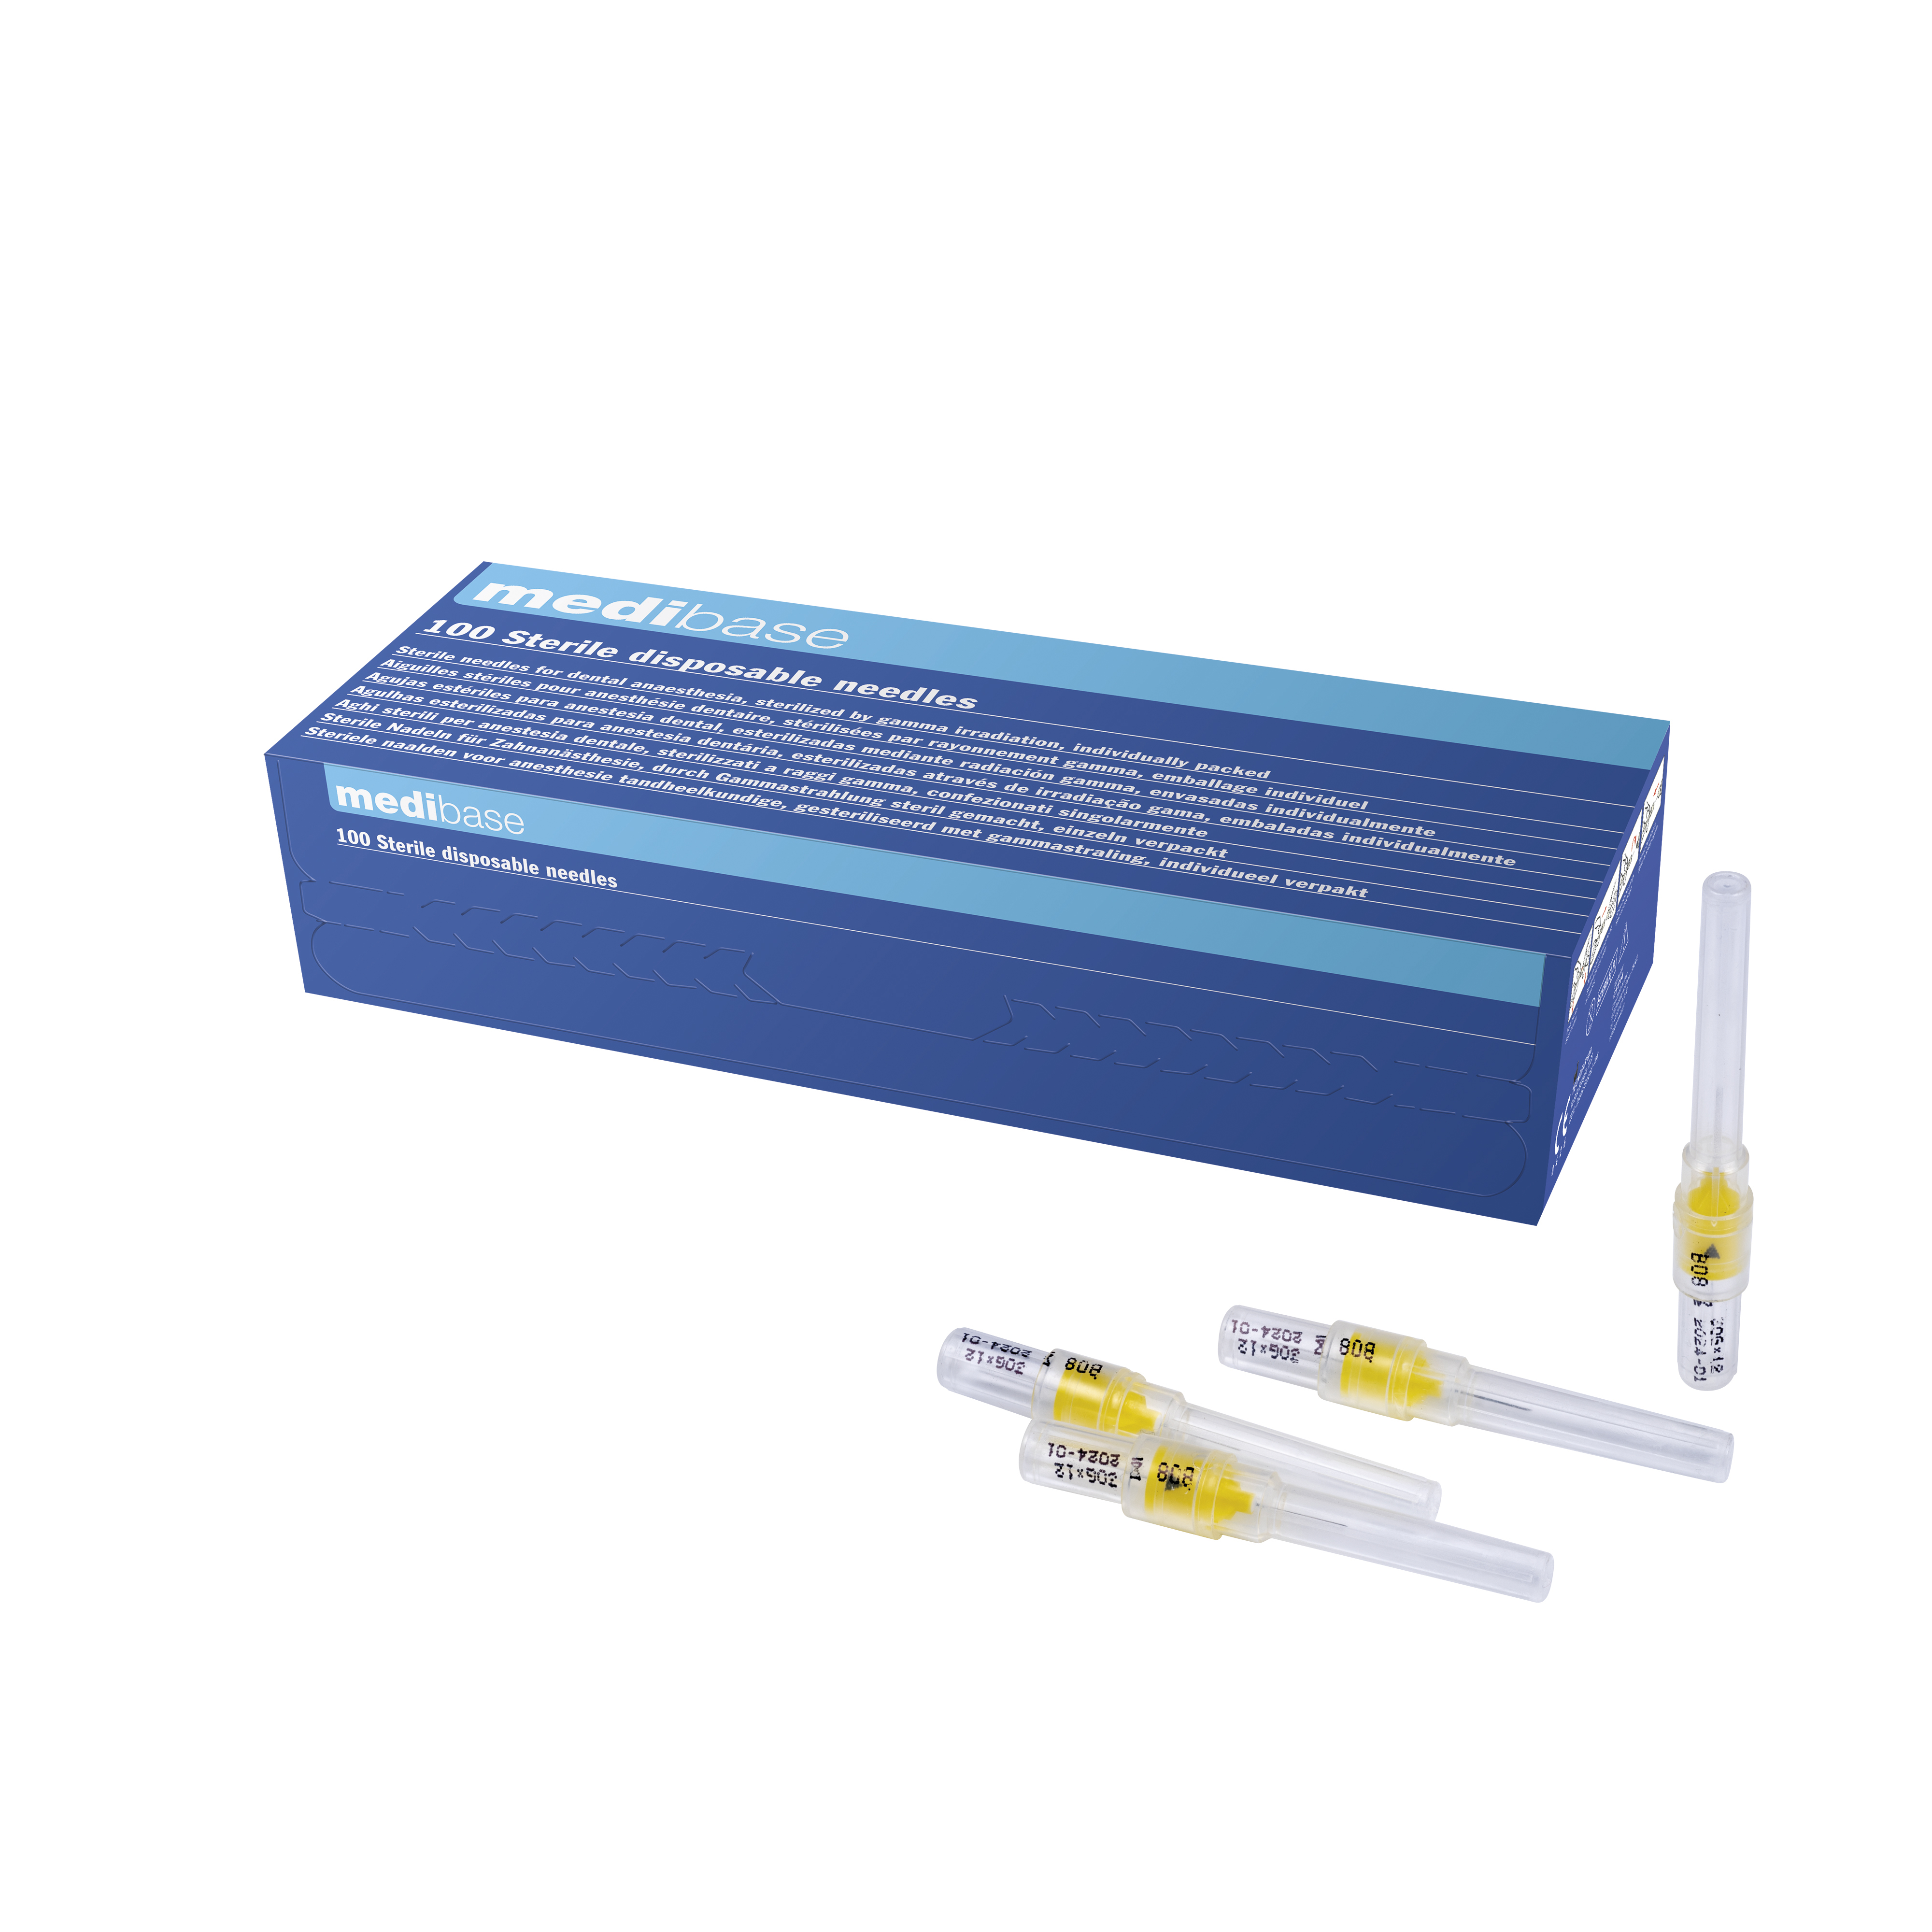
Description | Sterile needles for single use
Features and Technical Data | - Excellent quality, with silicone coating  - Triple bevel for a gentle injection  - Sterile with sterilization control ring  - With bevel indicator  - Sterilized with ethylene oxide  - Cannula: stainless steel  - Plastic part: polypropylene (PP)  - Lubricant: silicone
Packaging | Box of 100 needles
Lifetime | 5 years from the date of manufacture
Indications of use | 
legal informations | Class IIA medical device  CE Marking 0426. ITALCERT Notify body  Manufacturer: TECNOFAR SPA

Version 3.0 Update 14/11/2022 RG

