
TECHNICAL DATASHEET

Designation | Sterile non-woven swabs Medibase
Reference(s) | Size | 5x5 cm | 5x5 cm | 7,5x7,5 cm
Reference(s) | Box of | 150 swabs | 250 swabs | 80 swabs
Reference(s) | Internal conditioning | 75 pouches of 2 swabs | 50 pouches of 5 swabs | 40 pouches of 2 swabs
Reference(s) | Reference | 3135502 | 3135501 | 3135503
Product picture | 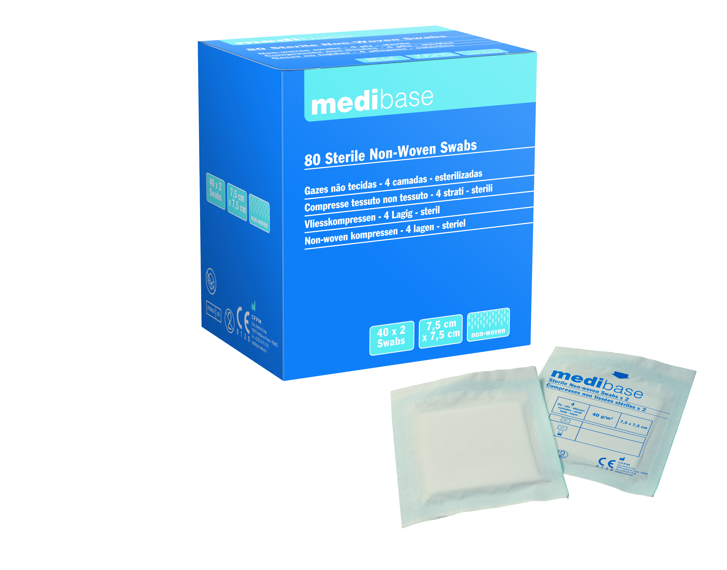
Product description | Non-woven swabs Medibase packed under sterile pouches
Characteristics and composition | Swabs 60% viscose / 40% polyester  - Number of plies : 4  - Sterilisation : ethylene oxide
Packaging | Available in two sizes (5x5 cm and 7,5x7,5 cm) and three conditioning
Shelf Life | 5 years
Indications of use | 
Legal information | Medical Ofvice of class I  CE 0123 Marking. Certifying body: TUV PRODUCT SERVICE  Manufacturer: FOMED Industries Inc
Version 2.0 Date : 14/11/2022 RG

