
TECHNICAL SHEET

Designation | Sterilisation pouches Medibase
Reference(s) | SELF SEALING POUCHES
Reference(s) | Size | 8,5 x 16,5cm |  | 7 x 25,5cm | 9 x 25,5cm | 14 x 28cm | 25,5 x 38cm | 5,7 x 13cm | 18 x 33cm | 9 x 13cm | 30 x 45 cm
Reference(s) | Ref | 3135469 |  | 3135470 | 3135471 | 3135472 | 3135473 | 3135474 | 3135475 | 3135476 | 3135477
Reference(s) | HEAT SEALING POUCHES
Reference(s) | Size | 7 x 25,5cm |  |  |  | 9 x 25,5cm |  |  | 20 x 33cm AVEC SOUFFLET DE 5,5cm
Reference(s) | Ref | 3135479 |  |  |  | 3135480 |  |  | 3135478
Product picture | 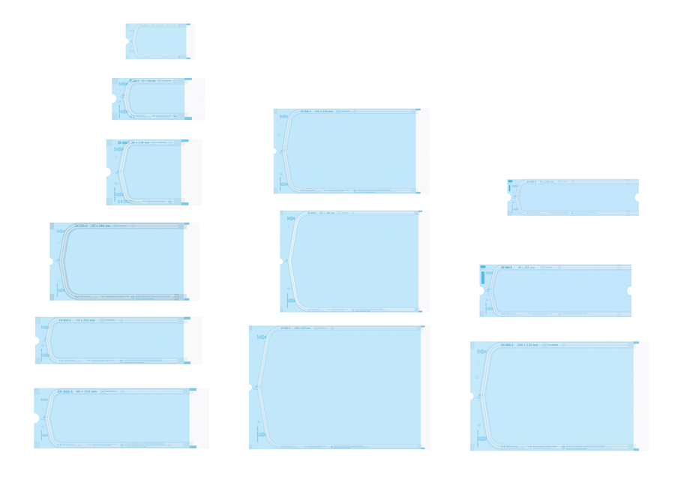
Product description | Sterilization bags recommended for autoclaving or chemiclave.
Characteristics and composition | Paper |  | The basis paper weight is ±60g/m², fitting the requirements of sterile packaging manufactured paper which list on ISO11607-1, 2 and EN868-5; According to the pouch designs, the printed inscription on the rolls is navy blue (Pantone298U), printing steam and EO indicator.
Characteristics and composition | Film |  | Lucid wathet blue hyperthermal PET/CPP complex film, thickness is ±0,052mm, weight is 56 g/m², conforming to the related requirements of EN868-5.
Characteristics and composition | Ink |  | Using ink; the min printing area of indicator should be 100mm², may not fade or become stained.
Packaging | Box of 200 pouches, available in 10 sizes
Shelf life | 5 years from manufacturing date
Indications of use | 
Legal information | Medical Device of class I  CE Marking  Manufacturer: FOMED Industries Inc
Version 2.3 Updated 15/11/2022 by RG

