TECHNICAL DATA SHEET

Designation | STERILIZATION ROLLS
References | 5 cm | 7,5 cm | 10 cm | 15 cm | 20 cm | 25 cm | 20 cm wide-sided depth 5,5 cm
 | 3134962 | 3134963 | 3134964 | 3134965 | 3134966 | 3134967 | 3134968
Visual | 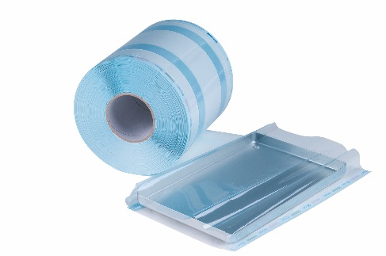  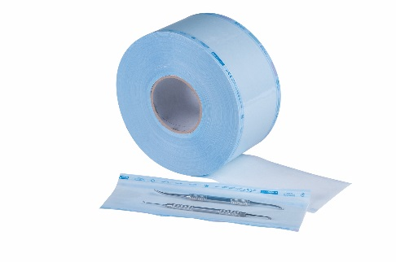
Description | Sterilization pouches in roll of 200 m, available in 6 different widths + one size wide-sided (roll of 100m).
Characteristics | Medical paper: 60 grams  PET films: 12/30 of blue color (12/40 for the girdle with bellows)  Every roll is individually packed under plastic film.  - Temperature of sealing of the bag: 170°C-200°C  - Steam sterilization  - 121°C in 134°C  - Indicators turn pink to brown  - Sterilization with oxide of Ethylene  - 30°C in 54°C  - Indicators turn green to yellow  - In accordance with the standards:  - 868:5  - ISO 11607: 1-2  - ISO 1140-1
Storage | KEEP IN DRY PLACE, KEEP AWAY FROM SUNLIGHT  DO NOT USE IF PACKAGING IS DAMAGED
Shelf-life | 5 years from the date of manufacture
Legal information | Medical device: class I  CE MARKING  Manufacturer: E-LINE
Version 3.1, updated by RG Date: 15/11/2022

