TECHNICAL SHEET

Product | SUPRATRAYS
Reference | QUADRANT | POSTERIEUR | ANTERIEUR | FULL ARCH | SIDELESS | QUADRANT RENF. METAL | POSTERIEUR RENF. METAL
 | 3134514 | 3134513 | 3134511 | 3134512 | 3134515 | 3134517 | 3134516
Number of pcs per box | 36 pcs | 36 pcs | 32 pcs | 28 pcs | 48 pcs | 36 pcs | 36 pcs
GTIN | 03665318008772 | 03665318008789 | 03665318008802 | 03665318008796 | 03665318008765 | 03665318008741 | 03665318008758
Picture | 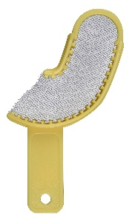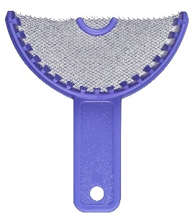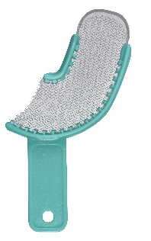
Description | Complete range of single-use impression trays for high quality footprints with ease.
Characteristics & Technical data | - Specially designed walls for extra retention.  - Easy handling and wide occlusal plane for easy access to all areas.  - High quality mesh, hard and resistant plastic.  - Easier access to difficult areas thanks to the thin metal reinforcement.  - Unrivalled firmness on single-use impression trays.
Storage | N/A
Indications of use
Shelf life of the product | N/A
Legal Information | Class I medical device. Manufacturer JOVIDENT INT. BV

