TECHNICAL SHEET

Designation | TIE-ON MASKS
Reference(s) | Blue
 | 3135073
Product picture | 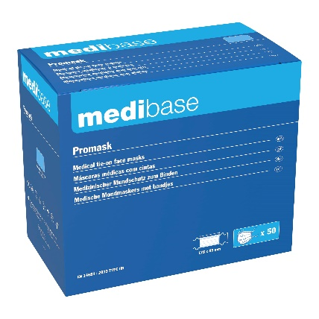
Product description | Medical tie-on masks, 3 plies, latex and fiberglass free. Complies with EN 14683 norm Type IIR.
Characteristics and compositions | Bacterial Filtration Efficiency (BFE): >99%.  • Respiratory resistance (ΔP): < 49 Pa/cm².  • Splash resistance: > 120 mm Hg.  • Dimensions: 8.9 cm x 17.8 cm.  • Integrated nose piece.  • 3 plies
Packaging | Box of 50 masks.  6 boxes per carton.
Shelf life | NA
Indications of use | 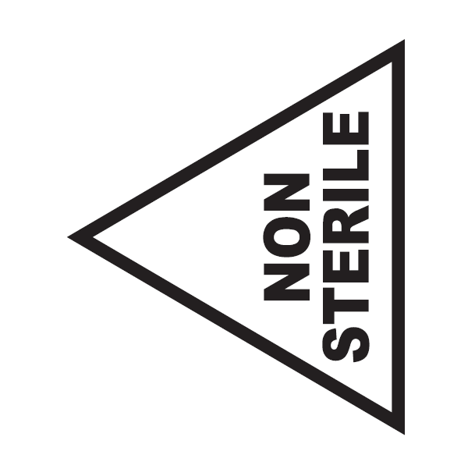  40°C  5°C
Legal information | Medical Device of class I under MDR 2017/745 regulation  EC Mark - Manufacturer A.R. MEDICOM INC. (Shanghai) Co., Ltd.

Version 1.0 – 03/01/2024

