
TECHNICAL SHEET

Designation | Medibase brush holders
Reference(s) | 3134142
Product picture | 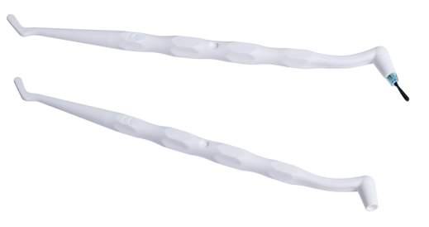
Product description | Plastic brush holders, cold sterilisation.
Characteristics and compositon | - Cold sterilisation  - Ergonomic, easy grip  - Combines spatula mouth  - Length: 147.50 mm (+/- 1 mm)  - Polypropylene – 99%  - Cadmium free pigments – 1%
Packaging | - Pack of 10 plastic holders
Shelf life | n.a
Indications of use | 
Legal information | Medical Device of class I under European Directive 93/42/EEC including Directive 2007/47/CE  Manufacturer: NOVOBRUSH
Version 1.1 Updated 15/11/2022 by RG

