TECHNICAL SHEET
Designation | Sterile Cannulas 2.5 mm MEDIBASE (20 cannulas + 2 adapters)
Reference(s) | 3149405
UDI-DI | 03700425946972
Visual | 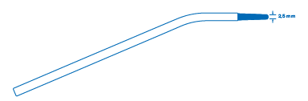  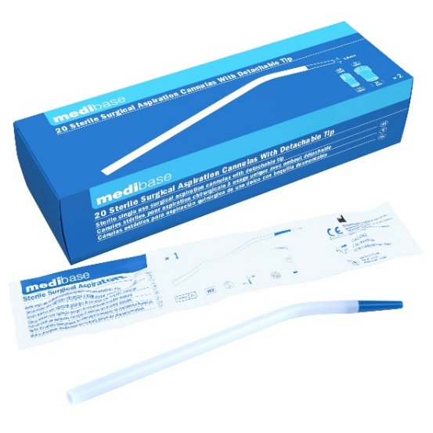
Description | Sterile single-use surgical suction cannulas with detachable tips.
Characteristics and Technical Data | Composition: PVC  Each cannula is individually packed in a sterile pouch:  - Hygienic  - Time-saving  The shape and length of the cannula and tip offer the following advantages:  - Precise suction  - Clear field of vision  - Access to narrow areas  The tip is removable, allowing switching from a 2.5mm diameter suction (with tip) to a 4.8mm diameter suction (without tip).  Each box contains two double adapters for connection to 11/16mm tubes.  The double adapters are supplied non-sterile and can be sterilized at 134°C.  The sterilization method used is ethylene oxide.
Packaging | Box of 20 cannulas + 2 double adapters.  Carton of 20 boxes.
Shelf life | 3 years from the manufacturing date.
Indications for use | 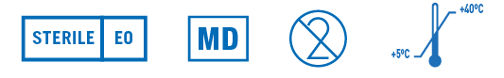
Legal information | Medical device of Class IIA under the European Directive 93/42/EEC  CE Marking 0197 - TUV RHEINLAND

Version 1.0 Updated 07/08/2023 by LF

